**WEEK 3:**

Write SQL Select Statements for the following simple queries that retrieve data from a single table:

1. Find the details of all students.

select * from student;

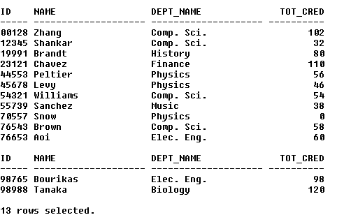

2. Find the department names of instructors.

select name, dept_name from instructor;

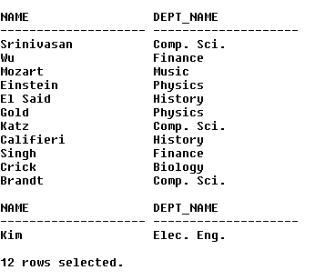

3. Find the names of all the instructors from Biology department.

select name from instructor where dept_name like 'Biology';



4. Find the names of all instructors in the Computer Science department who have salaries greater than $70000.

select name, salary from instructor where dept_name like 'Comp. Sci.' and salary > 70000;

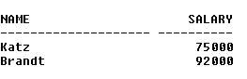

5. Find the names of courses in Computer science department which have 3credits

select title from course where dept_name like 'Comp. Sci.' and credits like 3;



6. Find the names of the instructors, their present salaries and the resulting salaries if they were given a 10% raise.

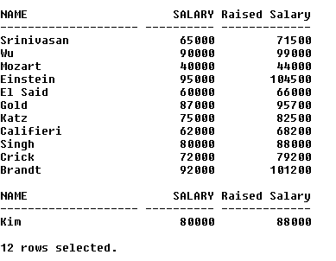select name, salary, (salary*1.1) as "Raised Salary" from instructor;

7. Find the names of instructors with salary amounts between $90000 and $100000.

select name, salary from instructor where salary between 90000 and 100000;

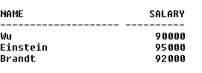

8. Find all instructors whose salary is unknown.

select * from instructor where salary is null;



9. Find the names of all departments whose building name includes the substring 'Watson'.

select dept_name, building from department where building like '%Watson%';

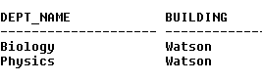

10. Find departments whose names contain the string "sci" as a substring, regardless of the case.

select * from department where lower(dept_name) like '%sci%';



11. List the names of all instructors in the Physics department in alphabetic order.

select name from instructor where dept_name like 'Physics' order by name asc;

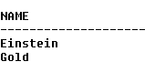

12. List the entire instructor relation in descending order of salary. If several instructors have the same salary, order them in ascending order by name.

select * from instructor order by salary desc, name asc;

